Denon DP47F
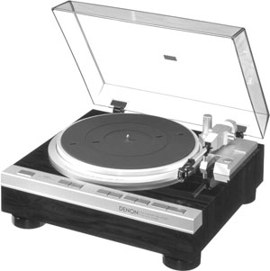

Description
The Denon DP-47F features a low mass tonearm with Q-damping method.
Low frequency resonance caused by the cartridges compliance and the effective tonearm mass is electronically damped both horizontally and vertically to effectively suppress crosstalk and inter-modulation distortion.
The dynamic servo tracer maximises the performance of the low mass tonearm and results in a record reproduction of excellent sound image with minimum noise and distortion.
By pressing the locate button, the tonearm is moved to any desired location where the record play is started.
The DP-47F also features Denon's quartz bidirectional servo and electronic braking system combined with a magnetic recording detector.
The quartz lock ensures stable performance of rotation and a sharp operation.

Specifications
Drive system: servo controlled direct drive
Speeds: 33.33 and 45rpm
Wow and flutter: below 0.010% WRMS
S/N ratio: over 78dB
Platter: 310mm aluminium die-cast
Motor: linear drive
Speed control system: speed servo by frequency detection, phase servo control
Arm type: dynamically balanced, straight tube tonearm
Effective length: 220mm
Overhang: 16mm
Dimensions: 434 x 179 x 410mm
Weight: 8.5kg

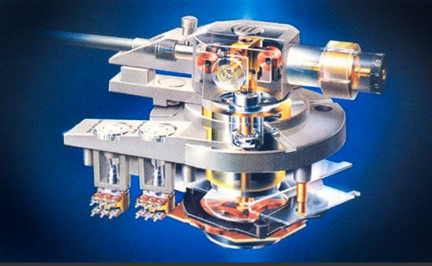
The dynamic servo tracer low-mass straight arm is carried in the tone arm.
He avoids the influence of the super-low-pass abnormal-conditions noise which produces fo by the curvature of a record etc. by setting it as around 10Hz as a straight arm of a low-mass, and also is trying to become the outside of an audio frequency band.
Furthermore, Q is held down to ideal conditions by the dynamic servo tracer. This detects a very detailed motion (horizontal and vertical) of a tone arm with a detector coil, is a system which controls the current sent through a drive coil, controls the power in which an arm moves by fo point to the opposite direction of vibration of a needle by this, and is improving trace capability sharply.
The vertical-axis drive coil of the dynamic servo tracer mechanism was operated, and aptitude needle pressure has been obtained.
The electronic formula anti skating mechanism is carried, the current which flows into the horizontal drive coil of an arm is controlled, and while the always suitable amount of cancellations is obtained with the structure which cancels an inside force where it does not contact, there is no sensitivity fall by mechanical friction.
AC servomotor which has the feature that there are essentially few electric noises and cocking does not occur in a motor is carried.
The speed-servo mechanism of DENON Quartz which combined the Quartz lock with the magnetic record detection system with high speed detection accuracy is adopted.
The system of the turntable which a wow and flutter can detect best which carries out speed detection on the perimeter mostly is used for a magnetic record detection system, and it has detected 1000 pulse signals by which magnetic record was carried out in pitch exact to the inner side of the rim of the turntable perimeter by the magnetic head. The frequency detected by this detection system is 33. It is at 1 / the 3 rotation time, and was set to 555.5Hz, and since [ high ] the frequency as compared with general FG system, it excelled in detection accuracy and a response, and the stable high servo system of a gain has been realized.
The 2inch1 type is used for the head for magnetic record, and it is considered as the servo mechanism which has an effect in both directions. It not only carries out the servo of the delay of a rotating speed by this, but a response quick also at the time of a standup is shown, and it demonstrates the effect also at the time of the standup and falling of number-of-rotations change.
The electronic brake was adopted, after the end of a record performance, immediately after the needle point separated from a record side, brake operation started, after a turntable's stopping, brake operation was canceled, and the mechanism without counterrotation is realized.
The wood cabinet of a slim design is adopted as a cabinet, and real wood specular surface finishing is given.
Switches have adopted the thing of a feather touch of an illuminaned button switch.
The quick repeat system is adopted and it returns at the performance starting point of a direct record, without a tone arm returning to an arm rest at the time of a repeat performance.
The servomechanism is a marvel of miniature machine design, composed of a small electromagnet acting on an iron plate attached to the arm in a way to affect the balance. The electromagnet is driven by a small circuit board labelled, IIRC, ‘Arm Servo.’ First, obviously, you have to statically balance the cartridge and set the tracking force to the desired force, normally, to get in the range of the servo for which you then set the tracking force to the servo controller via a potentiometer.
The tracking force is maintaned by the servomechanism and that compensates, in real time, analog, for any variations in tracking force. That includes those caused by resonance of the arm/cart mass with the compliance of the carridge. The hype in the 70’s was focused on compensating for the effects of inertia-induced fluctuations in tracking force as the arm rides up and down on record warps. I believe both of these forms of compensation do work.
First, my Denon DP-72 tracks the worst warped records without any skips or audible effects- I mean records that look like fried tortillas with series of warps ½ an inch high.
The compensation for arm/cartridge resonance is less easy to quantify but I’ve used low-compliance cartridges in my Denon DP-72 that tracked perfectly in the straight, lightweight Servotracer arm. It still felt and looked "wrong" somehow and I guess I'd recommend against using a very low compliance cart in any straight, lightweight arms, in this case because it moves the resonance closer to the envelope of the servo system. The range of such a system to respond is, of course, limited and it’s possible that there could be an arm/cartridge resonance so high that the servo couldn't deal with it (that having to do with the bandwidth of the servo electronics), but that seems rather unlikely. In any case, its probably a good idea to match the arm mass and compliance in your servo arm. For the DP-72 and similar older servo models, Denon incuded a heavier S-shaped interchangable plug-in arm for use with low compliane MC's. They eventually stopped doing that and made the arms permanently mounted, I assume for cost and reliability. I believe Sony had interchabgeable arms on their Biotracers also.
The Servo Tracer arm only has electronic servo-control for VTF. Nothing else. The only arms to claim control over everything you note in your post are the linear trackers. But that's another chapter in The Saga of Excessive Technology... Never heard one of those dooolies that sounded great either, but I keep an open mind...
Denon also began using it on many of their best turntables (the Dynamic Servo Tracer tonearm), and continued using it until the 2000’s on the majority of their turntables, only stopping a few years ago.
In effect, all of the systems, such as damping, tracking force and anti-skating are developed using linear motors, which of course, consist of coils of wire and magnets, with no physical contact existing, and thus no friction (because the magnets don’t touch the coils). They apply tracking force by developing a torque in the motor to push the tonearm down onto the record. Other coils are used to develop voltages as the tonearm moves (in the same manner as an electric generator), and torques are then generated in the relevant motor coil to move the tonearm to counteract unwanted movement. This occurs very quickly (nanoseconds), so mis-tracking due to off-centre records or warped records will never occur.
As David said, it almost completely eliminates inter-modulation distortion, by reducing tonearm/cartridge resonance to a very low value (less than 3dB). It can be seen very clearly on an oscilloscope trace of a sine wave, by stopping on one cycle. With non-electronic tonearms, several different overlaid frequencies caused by inter-modulation can clearly be seen, and with the electronic tonearms, all the other unwanted frequencies (i.e. the IMD) have disappeared, leaving just the pure tone.
A more complete description of the system JVC uses is available on page 3 of this brochure http://www.vinylengine.com/library/j...rntables.shtml . I started writing out a description, but it was taking so long that I decided to refer you to the above link. Denon and Sony also have descriptions of it in the brochures available on Vinylengine, and while they differ slightly in name and implementation, the systems are almost identical in how they work, and the results are identical.
__________________

